Project Design Phase-II
Data Flow diagrams and User stories

Date | 12 October 2022
Team ID | PNT2022TMID28577
Project Name | Predicting the energy output of wind turbine based on weather condition
Maximum Marks | 4 Marks

Data Flow Diagrams:

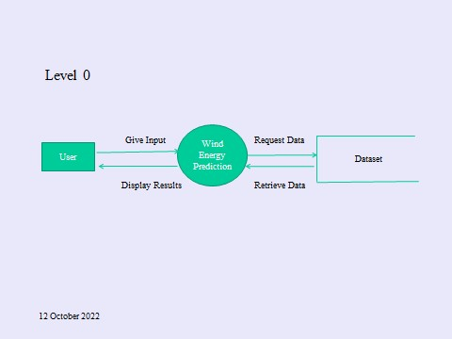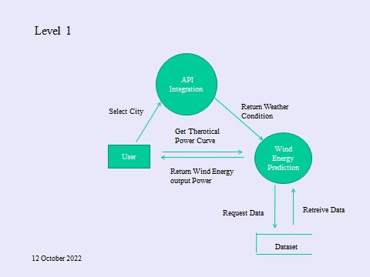

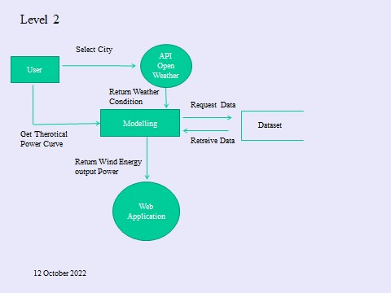

User Stories:

User Type | Functional  Requirements | User  Number  Story | User Story/User Task | Acceptance  Criteria | Priority | Release
Customer | Home(Application) | USN-1 | As a user, I can view the guideline as well as the detailed information about the application | I can gain knowledge by practical method to use  this application . | Low | Sprint-1
 |  | USN-2 | As a User, I can use this application by reading the instructions | I can use this in user friendly method by reading the instruction. | Low | Sprint-1
 |  | USN-3 | As a User, I can login and by entering the  correct username and password | If login is correctly entered ,I can navigate to the next page. | Low | Sprint-2
 |  | USN-4 | As a user ,I am allowed to select the city and can get the weather of the city. | I can select the city ,If the city is correct I can further enter the details. | Medium | Sprint-3
 |  | USN-5 | As a user I am allowed to view the weather of the selected city. | If correct city is selected ,then the weather of the particular city will be displayed. | Medium | Sprint-4
 |  | USN-6 | As a User ,I can view the Power generated by the wind | If all values are entered correctly I can view the power generated by the | High | Sprint-5
 |  | USN-7 | As a User, I can use the web application  virtually  anywhere | I can use the application portably | High | Sprint-2
 |  | USN-8 | As it is open source ,I can use it cost freely. | I can use it without any payment to access | Medium | Sprint-2

